Sususave
User Manual
How to run and use your susu group on the internet, explained in plain words.
The app lives at: https://sususave.vercel.app
October 2026

What is in this manual
- 1. What is Sususave? The idea, in plain words.
- 2. Opening the app. The web address and the front door.
- 3. For the admin: setting up your group. Account, group page, join code, the order of turns.
- 4. For the admin: running the group. Ticking off cash on payment day.
- 5. For members: joining and signing in.
- 6. For members: using the app. Home, Schedule, Payments.
- 7. Common questions.

1. What is Sususave?
A susu is a savings circle. A group of people agree to put in the same amount of money on a regular day, for example GH₵ 50 every week. Each time, all the money (the pot) goes to one person. Next time it goes to the next person, and so on, until everyone has had a turn.
Sususave is a website that keeps track of all of this for you. It remembers who is in the group, whose turn it is to receive the pot, who has paid and who has not. Everyone in the group can look at it on their phone and see the same numbers.
Important: no money moves through the website. People still hand over real cash to each other, the same way they always have. The website is just the notebook, so nobody has to argue about who paid.

Two kinds of people use it
- The admin. The person who runs the group. The admin creates the group, says how much everyone pays and how often, shares the join code, and ticks off cash as it is handed over. There is one admin per group.
- Members. Everyone else. A member signs in to see whose turn it is, how much to pay, when, and a list of their own payments.

Words you will see
Word | What it means
Pot | All the money collected in one round, which goes to one person.
Round or Turn | One payment day. Round 1 is the first collection, round 2 the next, and so on.
Collector | The person who receives the pot in that round.
Join code | A short code, like V53VED, that lets a person join your group.
Sign-in link | A special web link the admin can send to a member. Tapping it signs them in with no typing.
Order | The list that says who receives first, second, third...

2. Opening the app
Open the internet browser on your phone or computer (Chrome, Safari, Edge, any of them) and type this address at the top:
https://sususave.vercel.app
You will see the front door of the app. It has two tabs at the top of the white box: Member and Admin. Members use the left one, the admin uses the right one.
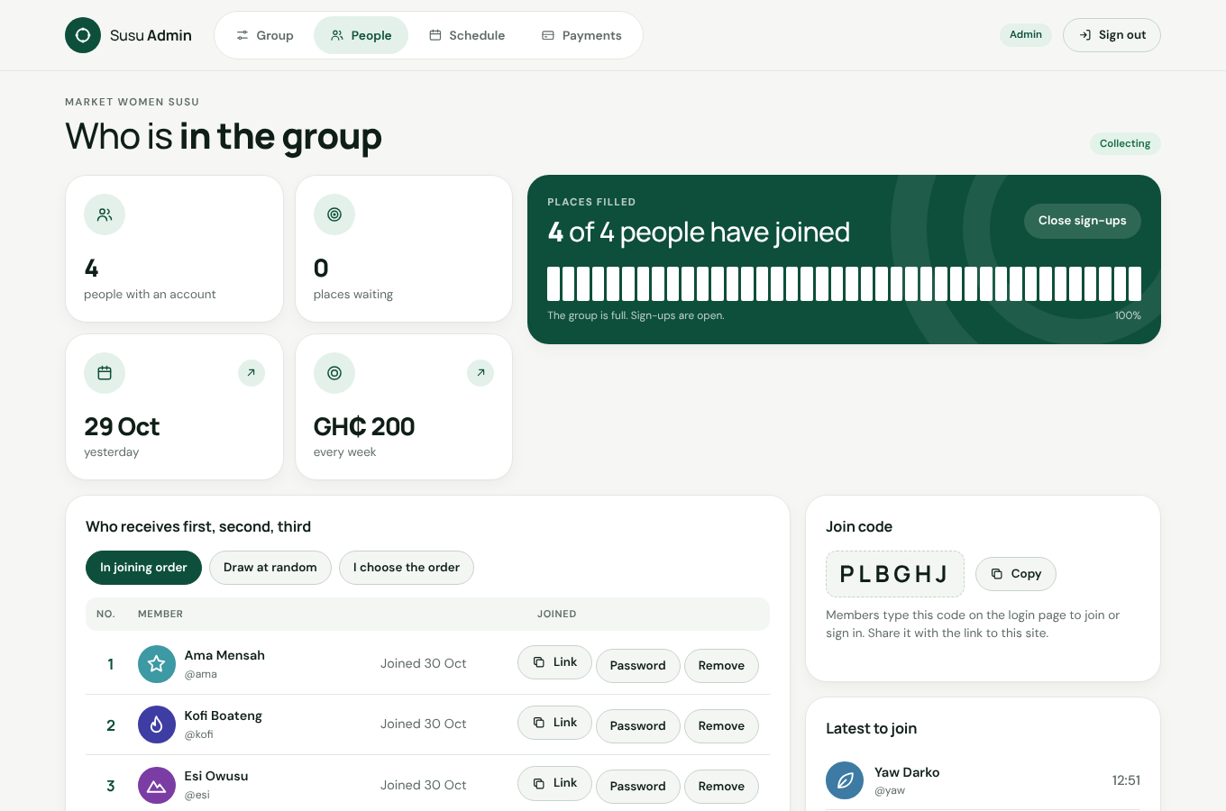
The front door. Choose Member or Admin.
Tip: On a phone, you can add the app to your home screen so it looks like a normal app. In Chrome, tap the three dots and choose "Add to Home screen". In Safari on iPhone, tap the share button and choose "Add to Home Screen".

There is nothing to install and nothing to pay. The app works on any phone with internet.

3. For the admin: setting up your group
Do this once, at the very beginning. It takes about five minutes.

3.1 Create the admin account
- Open https://sususave.vercel.app and tap Admin.
- Tap Starting a new group? Create the admin account.
- Type a username (a short name you will sign in with, for example "auntie-ama"), a password of at least 8 characters, and your group name (for example "Market Women Susu").
- Tap the big green button. You are now signed in as the admin.
Tip: Write your username and password somewhere safe. There is only one admin account for a group, and there is no "forgot password" for the admin.

3.2 Fill in the Group page
The app takes you to the Group page. It asks simple questions. Answer them and tap Save group and open sign-ups.
Question | What to put
What is your group called? | The name your members know.
How many people are in the group? | The total number of people, including you if you also pay in.
How much does each person put in? | The amount in cedis each person pays per round, for example 50.
How often does everyone pay in? | Every week, every two weeks, every month, or your own choice.
When is the first collection? | The date of the first payment day.
More options | How many times it should go all the way round, whether the collector keeps a small fee, and whether the collector also pays in on their own round. Leave these alone if you are not sure.
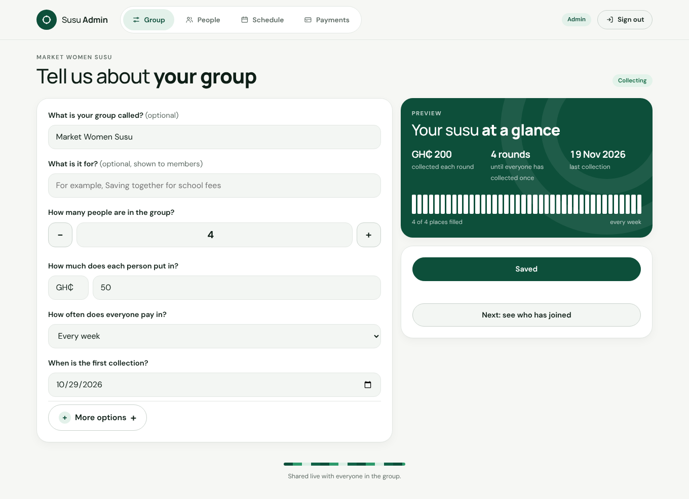
The Group page. The green box on the right shows what the group will look like.
The green box on the right updates as you type. It shows the size of each pot, how many rounds there will be, and when the last collection is.
Tip: You can come back and change these answers later, but it is best to get them right before people join. Changing the amount after people have paid can confuse everyone.

3.3 Get people to join
After you save, tap People at the top. You will see your join code, a short code of six letters and numbers. This is the key to your group.
Send every member two things, for example by WhatsApp:
- The address of the app: https://sususave.vercel.app
- The join code, exactly as shown (capital letters do not matter).
Each member then opens the app, taps New here? Join your group, types the code, and makes an account with their name, a username, a password and a picture. They get the next free number in the group.
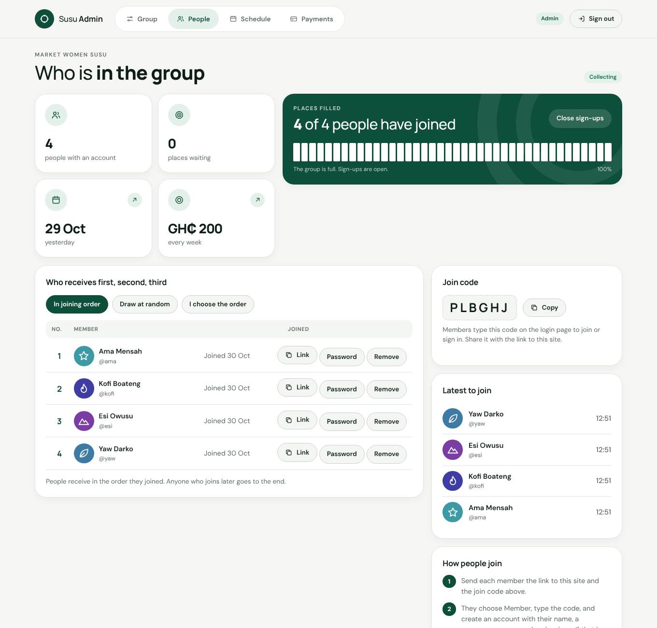
The People page: the join code, and who has joined so far.

3.4 If a member finds it hard to join
Some people are not comfortable typing codes and passwords. You can do it for them:
- On your own phone, open https://sususave.vercel.app in a private or incognito window (so it does not sign you out), tap Member, then New here? Join your group, and create their account with their name. Any username and password will do.
- Back in your admin app, on the People page, tap Link next to their name. A sign-in link is copied.
- Paste that link into a WhatsApp message to them. When they tap it, they are signed in straight away, with no typing at all. The link keeps working on that phone.
Tip: Treat a sign-in link like a key. Only send it to the person it is for.

3.5 Choose who receives first, second, third
On the People page there is a box called Who receives first, second, third. It has three buttons:
- In joining order. Number 1 is the person who joined first. This is how it starts.
- Draw at random. Tap it and the app shuffles everyone, like drawing names from a hat. Tap again to draw again.
- I choose the order. The list gets Up and Down arrows next to every name. Move people until you are happy, then tap Save this order. Tap Cancel to leave it as it was.
Anyone who joins later goes to the end of the list. Once the first pot has been handed over, the order is locked and the buttons stop working, so that nobody can change the order halfway.
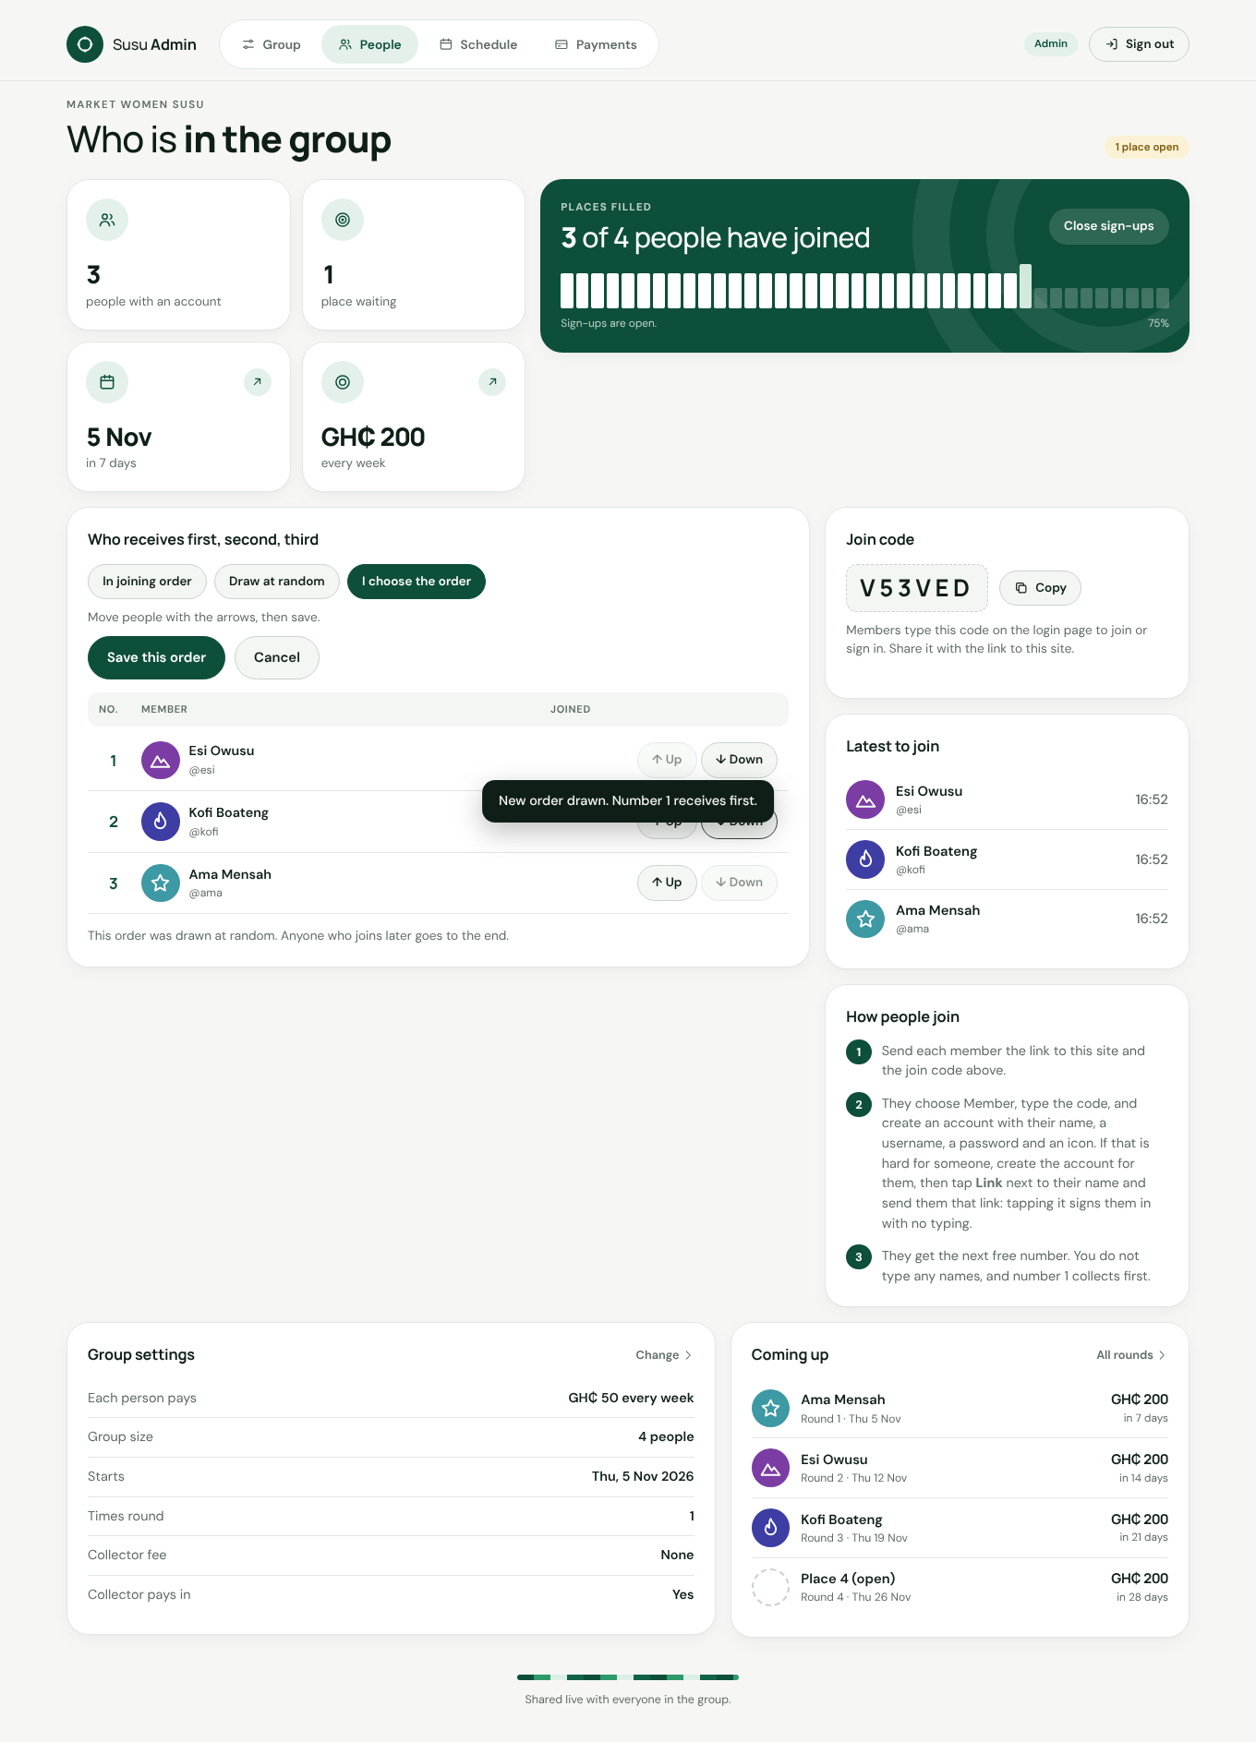
"I choose the order" with the Up and Down arrows.

3.6 Closing sign-ups
When all the places are filled, the group is full and nobody else can join. If you want to stop people joining before that, tap Close sign-ups on the People page. Tap it again to open them.

4. For the admin: running the group
This is what you do on every payment day. It takes a minute.

4.1 The Payments page
Tap Payments at the top. The big box on the right shows the current round: whose turn it is, how much they will receive, and a list of everyone with Not yet or Paid next to their name.
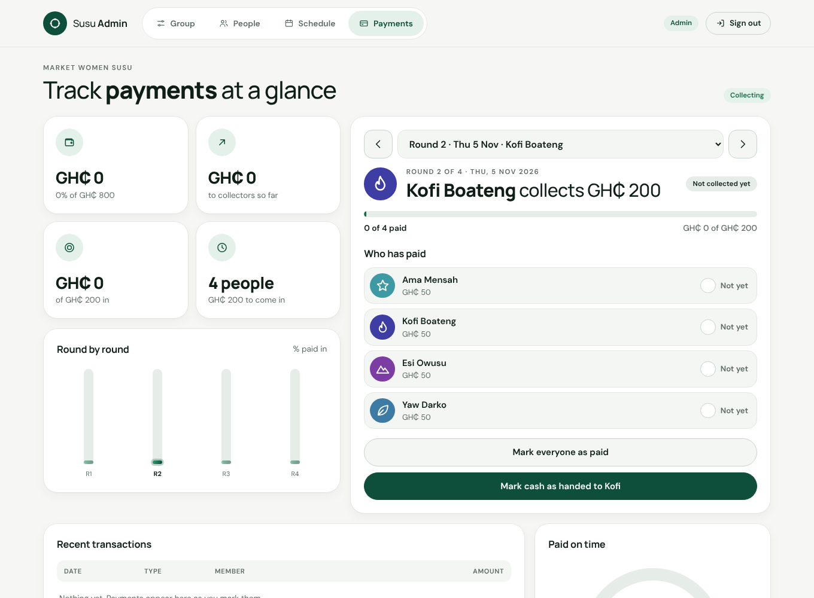
The Payments page. The box on the right is the round you are working on.

4.2 Ticking off cash
- When a member hands you cash (or hands it to the collector in front of you), find their name in the round box and tap Not yet. It turns into Paid, with the time and your name next to it.
- Tapped by mistake? Tap it again and it goes back to Not yet.
- If everyone has paid at the same time, tap Mark everyone as paid to tick them all at once.
- When the collector has the whole pot in their hand, tap Mark cash as handed to ... at the bottom of the box. That closes the round.
Every tick is remembered with who did it and when. Members see the same ticks on their phones straight away, so there is no need to send messages about who has paid.
Tip: The collector of the round can also tick people off, from their own phone. If the collector receives the money directly, they tap "I have received the cash" themselves. You can always see who ticked what.

4.3 Moving between rounds
Use the small arrows at the top of the round box to look at earlier or later rounds. The app always opens on the round that is due now.

4.4 Understanding the rest of the page
- Saved so far / Paid out. How much money has gone through the group, and how much has been handed to collectors.
- Behind on payments. People who still owe for a round that has passed. Talk to them.
- Recent transactions. The last few ticks, with who recorded them.
- Everyone’s totals. How much each person has paid in and received, over the whole susu.

4.5 The Schedule page
Tap Schedule to see the whole plan: every round, its date, and who receives. Members see the same list. Nothing on this page needs tapping.
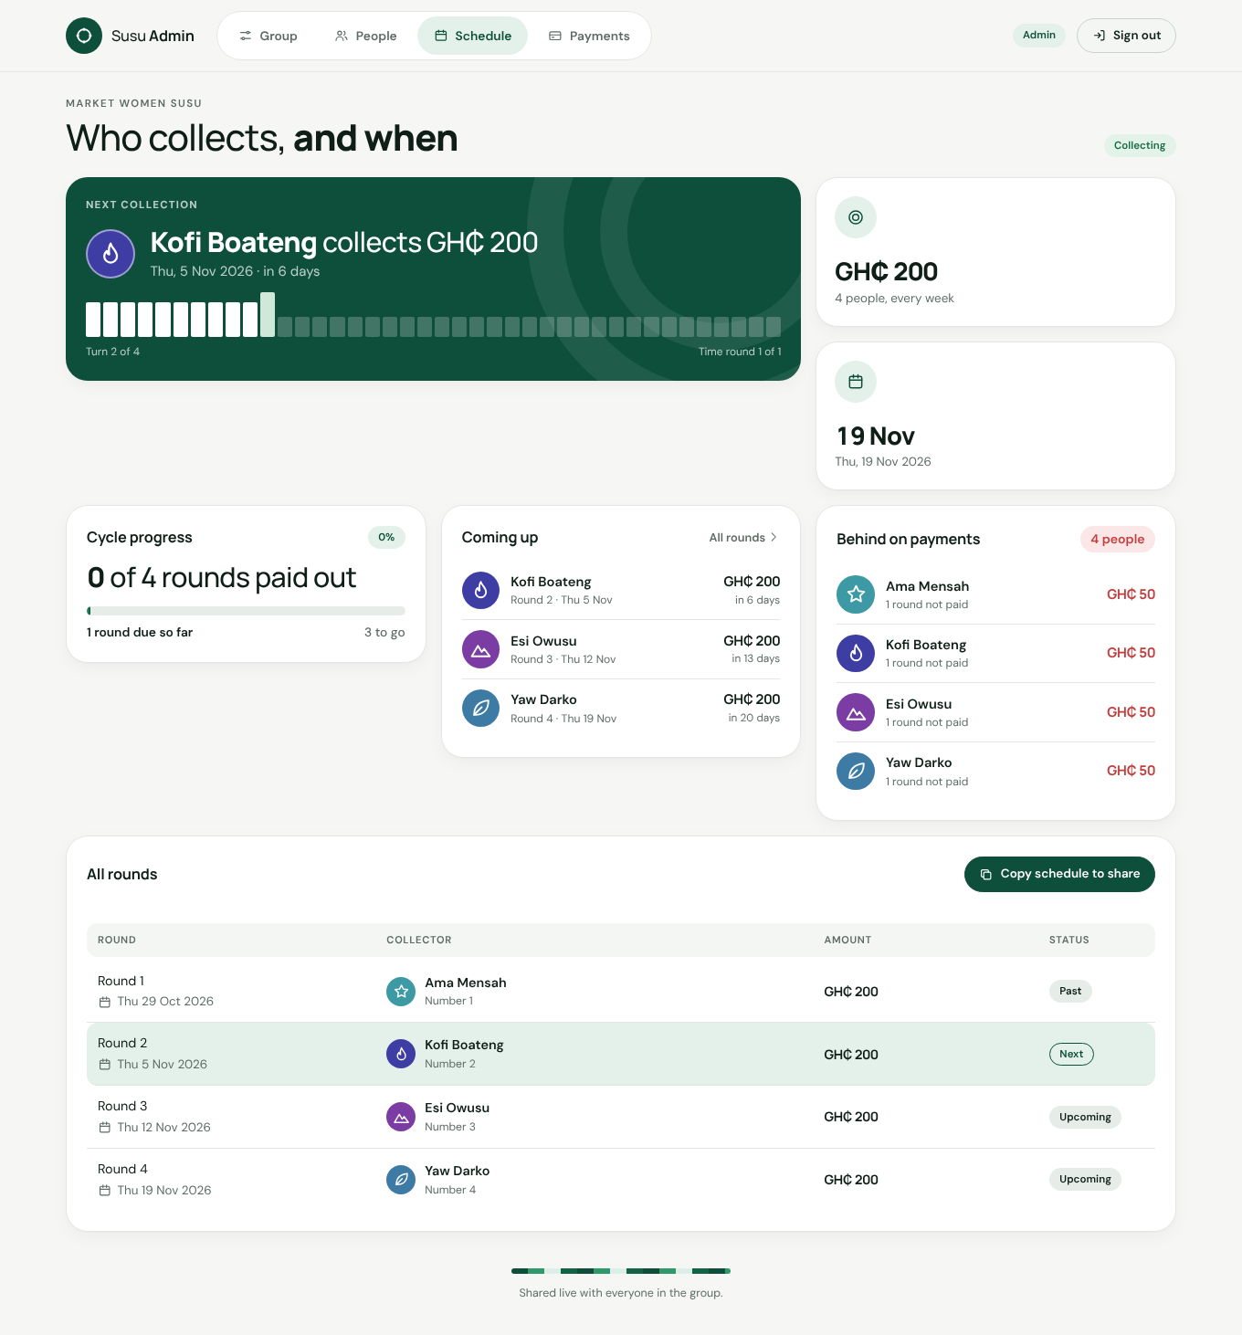
The Schedule page.

4.6 Helping members
Problem | What to do
A member forgot their password | People page, tap Password next to their name, type a new one and tell them.
A member cannot manage signing in at all | People page, tap Link next to their name and send them the link. Tapping it signs them in.
Someone left the group | People page, tap Remove next to their name, then tap it again to confirm. Their place opens up for a new person. You can only do this before the group starts paying out.
Someone wants to join but the group is full | Change "How many people" on the Group page, or remove a member first.
You want to see a member’s view | Tap Link next to their name and open that link in a private window.

4.7 Signing out
Tap Sign out at the top right. You stay signed in for 30 days if you do not, which is handy on your own phone, but sign out on a shared phone.

5. For members: joining and signing in

5.1 Joining for the first time
- Open https://sususave.vercel.app in your browser.
- Tap New here? Join your group.
- Type the join code your admin sent you and tap Next. The app shows the group name so you know you are in the right place.
- Type your full name (the name the group knows you by), a username (short, no spaces, for example "kofi"), and a password of at least 6 characters. Pick a picture you like.
- Tap the green button. You are in, and you are given your number in the group.
Tip: If your admin sent you a sign-in link instead, just tap the link. You do not need to do any of this.

5.2 Signing in next time
Your phone remembers you for 30 days, so usually the app just opens. If it asks you to sign in, tap Member, type the join code, your username and your password, then Sign in. If you forgot your password, ask your admin to set a new one.

6. For members: using the app
There are three pages, chosen with the three buttons near the top: Home, Schedule and Payments.

6.1 Home: what to do now
The Home page tells you the one thing that matters today in a big green box: who to give your money to, how much, and by when. Below it, a box called Your turn says when the pot comes to you.
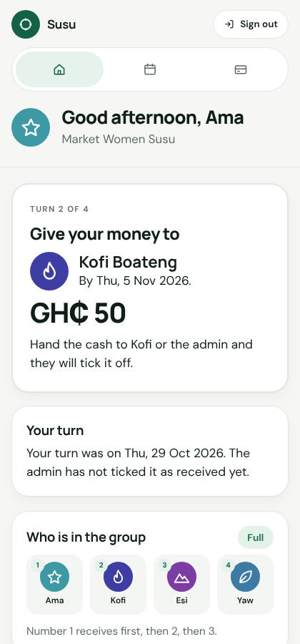
The Home page on a phone.
Further down you see everyone in the group with their numbers (number 1 receives first, then 2, then 3), and who receives in the next few rounds. Tap More about the group to see the totals.

6.2 Schedule: the whole plan
A list of every round with its date and who receives the pot. Your own turn is highlighted.

6.3 Payments: your money
Two lists:
- Your payments. Every round, with Paid or Not yet next to it. When you hand over cash, the admin (or the collector) ticks it, and it turns to Paid on your phone too.
- People paying you. Only shown on your own round. It lists everyone who should hand you cash. When someone gives you money, tap Not yet next to their name to tick it. When you have the whole pot, tap I have received the cash.
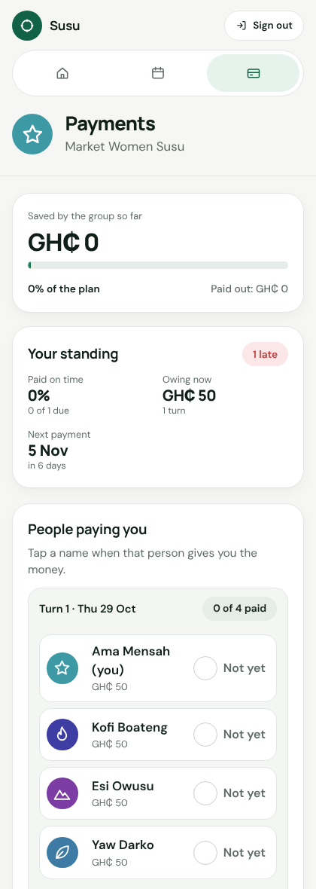
The Payments page on your own round.
Tip: Only the admin and the collector of the round can tick payments. If your payment still says Not yet after you paid, tell the admin so they can tick it.

6.4 Signing out
Tap Sign out at the top right. Do this if you used someone else’s phone.

7. Common questions
Question | Answer
Does the app take money from my phone or bank? | No. It never touches money. You pay cash as usual. The app only records it.
Do I have to install anything? | No. It is a website. Open the address in your browser.
Does it work without internet? | No. You need data or Wi-Fi to open it, but it uses very little.
Can two groups use it? | Yes. Each group has its own admin account and its own join code. Create a second admin account for the second group.
Who can see our numbers? | Only people signed in to your group. Nobody can get in without the join code and an account.
What if the admin’s phone is lost? | Sign in on any other phone with the admin username and password. Everything is saved on the internet, not on the phone.
The page says "That is not an admin username" | You tapped Admin but typed a member’s name. Tap Member instead, or check the spelling.
The page looks dark green | Your phone is in dark mode. The app still works. The newest version always shows white.
Something looks wrong or is confusing | Take a screenshot and tell whoever set up the app for you.

